Sample Hands-on Exercises on Edge Services and API Gateway with Spring Boot 3 and Spring Cloud
Exercise 1: Implementing Edge Services for Routing and Filtering
Pom.xml:
<?xml version="1.0" encoding="UTF-8"?>
<project xmlns="http://maven.apache.org/POM/4.0.0"
xmlns:xsi="http://www.w3.org/2001/XMLSchema-instance"
xsi:schemaLocation="http://maven.apache.org/POM/4.0.0
https://maven.apache.org/xsd/maven-4.0.0.xsd">
<modelVersion>4.0.0</modelVersion>
<parent>
<groupId>org.springframework.boot</groupId>
<artifactId>spring-boot-starter-parent</artifactId>
<version>3.5.3</version>
<relativePath/>
</parent>
<groupId>com.example</groupId>
<artifactId>edge-gateway</artifactId>
<version>0.0.1-SNAPSHOT</version>
<name>edge-gateway</name>
<description>Spring Cloud Gateway (WebFlux) Project</description>
<properties>
<java.version>17</java.version>
<spring-cloud.version>2025.0.0</spring-cloud.version>
</properties>
<dependencies>
<!-- Updated recommended dependency for Spring Cloud Gateway -->
<dependency>
<groupId>org.springframework.cloud</groupId>
<artifactId>spring-cloud-starter-gateway-server-webflux</artifactId>
</dependency>
<!--DevTools for live reload (optional but helpful) -->
<dependency>
<groupId>org.springframework.boot</groupId>
<artifactId>spring-boot-devtools</artifactId>
<scope>runtime</scope>
<optional>true</optional>
</dependency>
<!-- Unit Testing -->
<dependency>
<groupId>org.springframework.boot</groupId>
<artifactId>spring-boot-starter-test</artifactId>
<scope>test</scope>
<exclusions>
<exclusion>
<groupId>org.junit.vintage</groupId>
<artifactId>junit-vintage-engine</artifactId>
</exclusion>
</exclusions>
</dependency>
</dependencies>
<dependencyManagement>
<dependencies>
<dependency>
<groupId>org.springframework.cloud</groupId>
<artifactId>spring-cloud-dependencies</artifactId>
<version>${spring-cloud.version}</version>
<type>pom</type>
<scope>import</scope>
</dependency>
</dependencies>
</dependencyManagement>
<build>
<plugins>
<plugin>
<groupId>org.springframework.boot</groupId>
<artifactId>spring-boot-maven-plugin</artifactId>
</plugin>
</plugins>
</build>
</project>
Application.properties:
server.port=8080
spring.cloud.gateway.server.webflux.routes[0].id=example_route
spring.cloud.gateway.server.webflux.routes[0].uri=http://localhost:8081
spring.cloud.gateway.server.webflux.routes[0].predicates[0]=Path=/example/**
EdgeGatewayApplication.java:
package com.example.demo;
import org.springframework.boot.SpringApplication;
import org.springframework.boot.autoconfigure.SpringBootApplication;
@SpringBootApplication
public class EdgeGatewayApplication {
public static void main(String[] args) {
SpringApplication.run(EdgeGatewayApplication.class, args);
}
}
LoggingFilter.java:
package com.example.demo;
import org.springframework.cloud.gateway.filter.GlobalFilter;
import org.springframework.core.annotation.Order;
import org.springframework.stereotype.Component;
import org.springframework.web.server.ServerWebExchange;
import org.springframework.cloud.gateway.filter.GatewayFilterChain;
import reactor.core.publisher.Mono;
@Component
@Order(1)
public class LoggingFilter implements GlobalFilter {
@Override
public Mono<Void> filter(ServerWebExchange exchange, GatewayFilterChain chain) {
System.out.println("Request URI: " + exchange.getRequest().getURI());
return chain.filter(exchange);
}
}
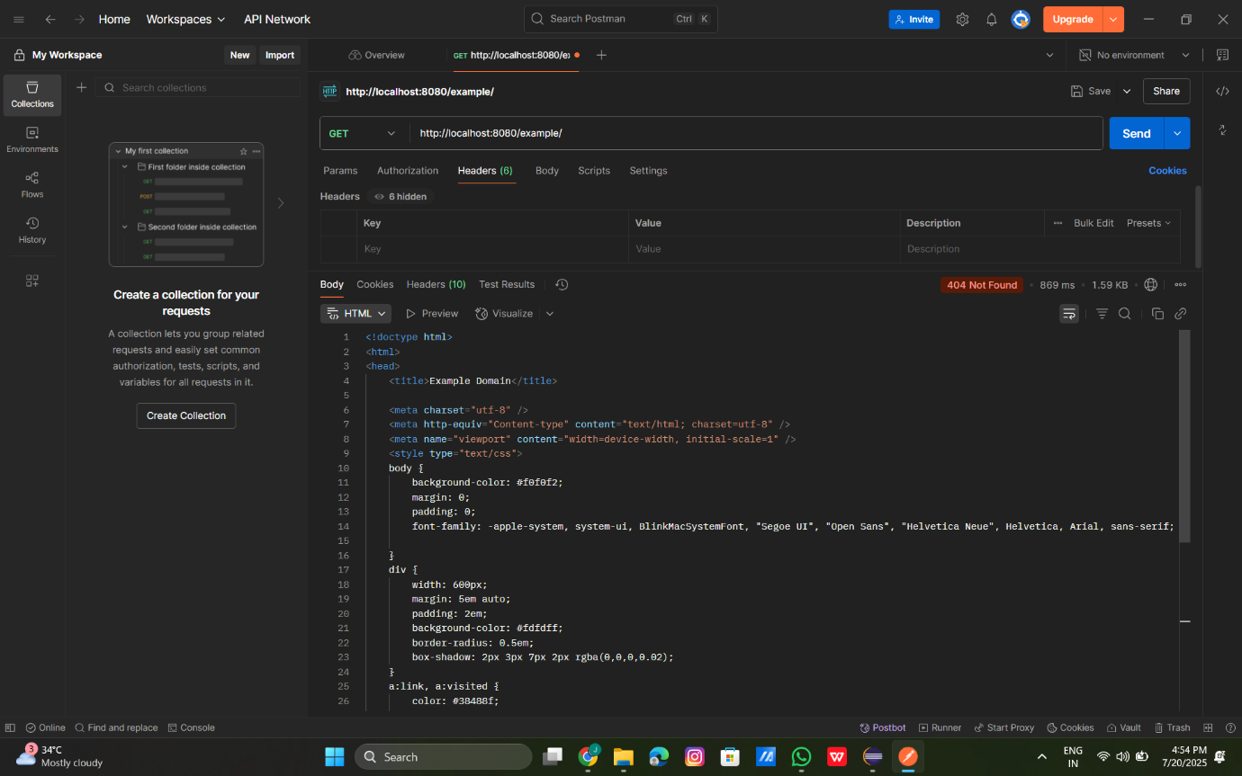

Exercise 2: Load Balancing in an API Gateway
HelloController.java:
package com.example.backend_service;
import org.springframework.web.bind.annotation.GetMapping;
import org.springframework.web.bind.annotation.RestController;
@RestController
public class HelloController {
@GetMapping("/example/test")
public String test() {
return "Response from port 8081 or 8082";
}
}
pom.xml (Edge Gateway):
<dependencies>
<dependency>
<groupId>org.springframework.cloud</groupId>
<artifactId>spring-cloud-starter-gateway-server-webflux</artifactId>
</dependency>
</dependencies>

application.properties (Edge Gateway):
server.port=8080
spring.application.name=edge-gateway
spring.cloud.gateway.discovery.locator.enabled=true
spring.cloud.gateway.routes[0].id=backend-service
spring.cloud.gateway.routes[0].uri=http://localhost:8081
spring.cloud.gateway.routes[0].predicates[0]=Path=/example/test
spring.cloud.gateway.routes[1].id=backend-service-2
spring.cloud.gateway.routes[1].uri=http://localhost:8082
spring.cloud.gateway.routes[1].predicates[0]=Path=/example/test
Outputs:
8080:
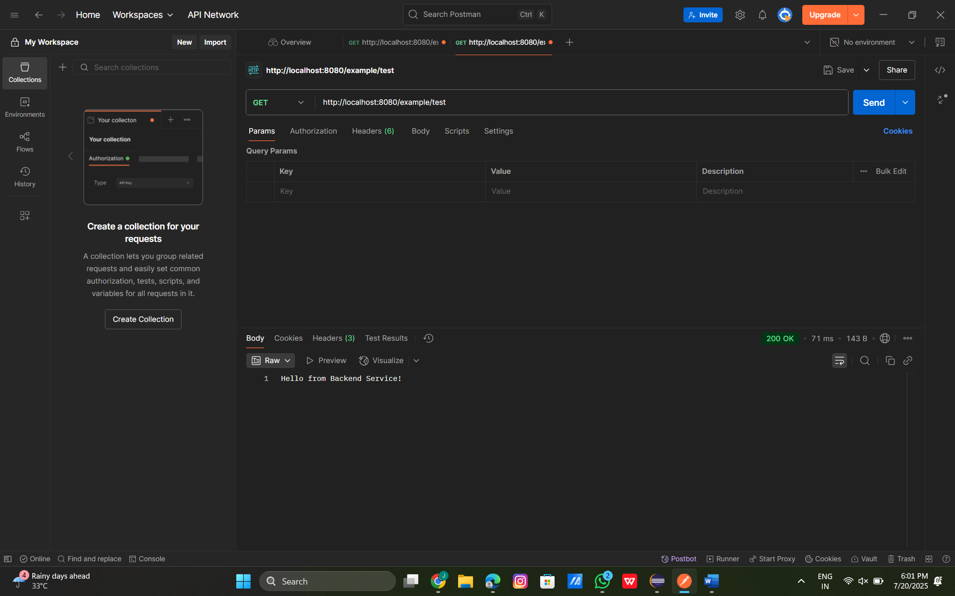
8081
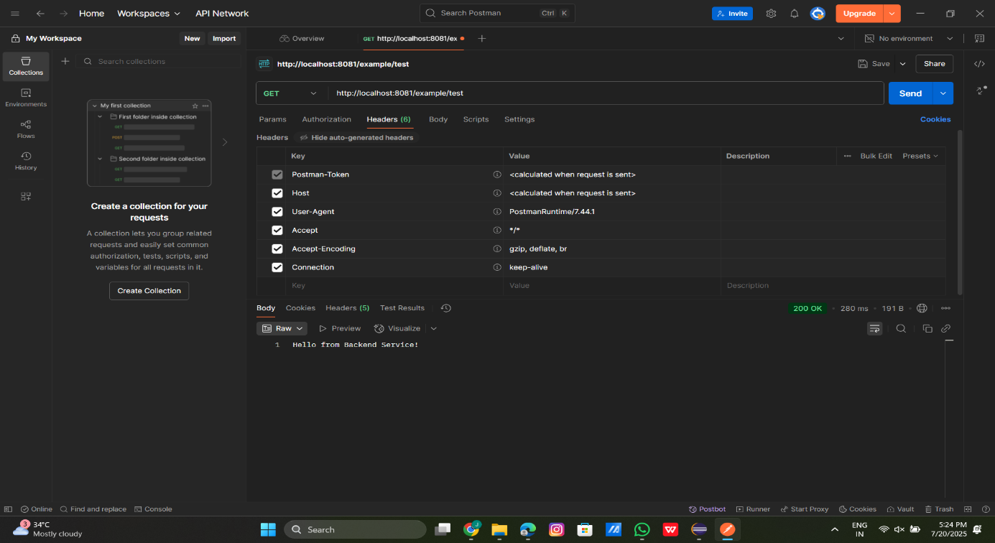
8082
